User Manual

T4C Edge – v1.1.0

**Copyright**

© Copyright 2023 DH Healthcare GmbH. All rights reserved.

No parts of this document may be reproduced, copied, adapted or transmitted in any form or by any means without the written permission of DH Healthcare GmbH.

DH Healthcare GmbH reserves the right to make changes to this document without prior notice.

A printed version is available upon request.

This product is a trademark of Dedalus S.p.A., Italy or its affiliates. All other trademarks are held by their respective owners and are used in an editorial fashion with no intention of infringement.

 DH Healthcare GmbH, Konrad-Zuse-Platz 1-3, 53227 Bonn, Germany

In this product, user settings and functionalities are determined by configuration options and security settings.

This product can be modified to support the workflows and methods that are used in your hospital.

As a result, the functionalities and screen settings that are described in this document might differ from what you can do and from what you see on your screen. The settings can also differ from department to department.

**Statement on gender-neutral terminology**

For reasons of legibility and clarity, gender-neutral terminology is used, e.g. User. Corresponding terms apply equally to all sexes.

**Document history**

Latest update of this document: 12/08/2023

<https://my.dedalusportal.com>



**Table of contents**

1 T4C Edge Portal 5

1.1 Document instructions 5

1.2 Introduction 5

1.3 Scope 5

1.4 Intended use 5

1.5 Indications for use 5

1.6 Statement of contra indications 6

1.7 Intended users 6

2 T4C Edge setup 7

2.1 Sign into T4C Portal 7

3 My Cohorts 9

*3.1* Manage Cohort 9

3.2 Field and Button Description – My Cohorts page 16

3.3 Field and Button Description – Manage Cohort page 17

4 Cohort History 19

4.1 Field and Button description - Cohort History page 19

5 Perform a research query – Cohort Builder 20

5.1 Build new query 20

5.2 View and use previous history 22

5.3 Modify and Save query research 23

5.4 Field and Button Description – Cohort Builder page 23

6 My Saved Cohorts 26

6.1 View research 26

6.2 Edit research 26

6.3 Duplicate research 27

6.4 Delete research 27

*6.5* Subscribe and Favorite research 28

6.6 Field and Button Description – My Saved Cohorts page 29

7 Overview of Edge available resources – Discover page 30

8 Settings 31

8.1 User management 31

8.2 NLP score setup 34

8.3 Field and Button Description – Settings page 35

9 Logs 37

9.1 Review internal organization history 37

9.2 Field and Button description – Logs page 37

10 Documentation 39

10.1 Field and Button description 39

11 References 40

11.1 Generic references 40

12 Appendix 42

12.1 Glossary 42

12.2 FAQ 42

13 Amendment History 44

# T4C Edge Portal

## Document instructions

This chapter contains information about the scope and for the effective operation of **Trials4Care (T4C) Edge portal**.

## Introduction

T4C Edge portal is connected to the Hospital EMR system and helps to visualize the search results. You can define specific criteria to get real information from a pool of data.

The goal is to assist with a trial process or simulation. T4C Edge portal is primarily used to review and process Expressions of Interest requests from external research organizations.

The following features described in the manual are only of relevance for the version of T4C Edge 1.1.0:

* Perform specific criteria search.
* Manage the general data sharing policies of the organization.
* View and manage expression of interest request(s) from external research organizations to participate in a trial.

You can access the portal data from several locations in the right navigation panel.

## Scope

This document is valid for T4C Edge portal version 1.1.0

## Intended use

The intended use of the T4C platform is to bridge the gap between the healthcare providers and the life science ecosystem by enabling researchers to more effectively search for suitable patients that match their trial criteria.

T4C Edge portal securely links researchers and a dispersed pool of patients using a set of technologies, processes and systems that ensure patient data is shared safely, legally, and ethically for secondary use.

## Indications for use

T4C Edge portal is used by hospital-based trial coordinators to review and process incoming Expressions of Interest requests from external research organizations. If the incoming Expression of Interest request is suitable, they can record/navigate through several steps including checking patient suitability, recording ethics approval status, recording patient consent with the external research organization.

## Statement of contra indications

This document provides user guidance only on T4C Edge portal and not the Analytics capability.

T4C Edge portal is not intended to receive or send data to external applications.

Cohort information in the portal should only be used for external research opportunities received via the Expressions of Interest workflows.

## Intended users

This document is written for subscribed users of T4C Edge portal.

Users are considered as active subscribers accounts with contractual agreement with Dedalus Healthcare.

### Roles and Permissions

|  |  |
| --- | --- |
| Role | Permissions |
| **Hospital Research Coordinator** | Trial coordinator who review and process all the Expressions of Interest requests from external research organizations. |

# T4C Edge setup

T4C Edge portal installation is done by T4C team as part of the service legal agreement and creates the first Hospital’s role.

1. Check the Email provided by T4C team and follow the instructions of the created account in T4C Edge portal.
2. Click **T4C Edge portal** link portal set up page received in the email body.
3. Enter a **username** for your account.
4. Enter your **password**. It should include at least:
   * 1. 8 characters length.
     2. One letter.
     3. One number.
     4. One special character (@%+\/' ! # $ ^ ?:.(){}[] ~-_).
5. Click **Submit**.
6. Click **OK** in confirmation message displayed.

Now you will be able to log in into T4C Edge portal with your created credentials.

**Restriction:**

Organization ID cannot be modified.

## Sign into T4C Portal

1. Go to **T4C Edge portal**.

Instruction:

Always use the official URL provided by T4C team to avoid security credentials sharing risks.

1. Enter your **username**.
2. Enter your **password**.
3. Click **Sign In**.

**Restriction:**

Only existing users can login in T4C Edge portal.

Credentials such as email, username and password are unique and should be used

by the registered user. Do not share your credentials.

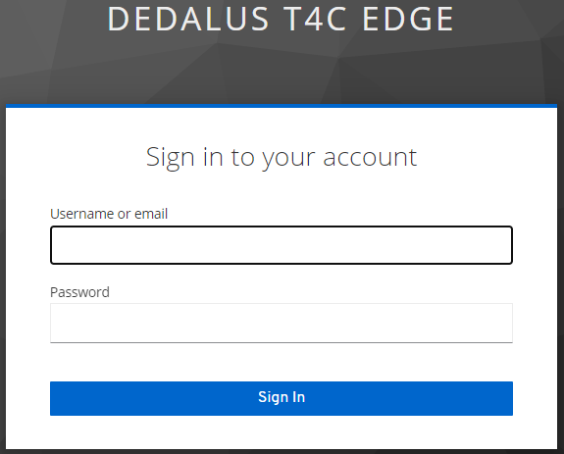

Login page

# My Cohorts

This page displays the list of **Expression of Interests (EOI)** received and allows you to start the enrollment process.

In the **My Cohorts page,** in the left menu of the T4C Edge portal, the upper part is dedicated to the counter, which provides a preview of the total number of patients per index, available on the Edge. Immediately below, a table is displayed, containing a set of information related to the list of expressions of interest received.

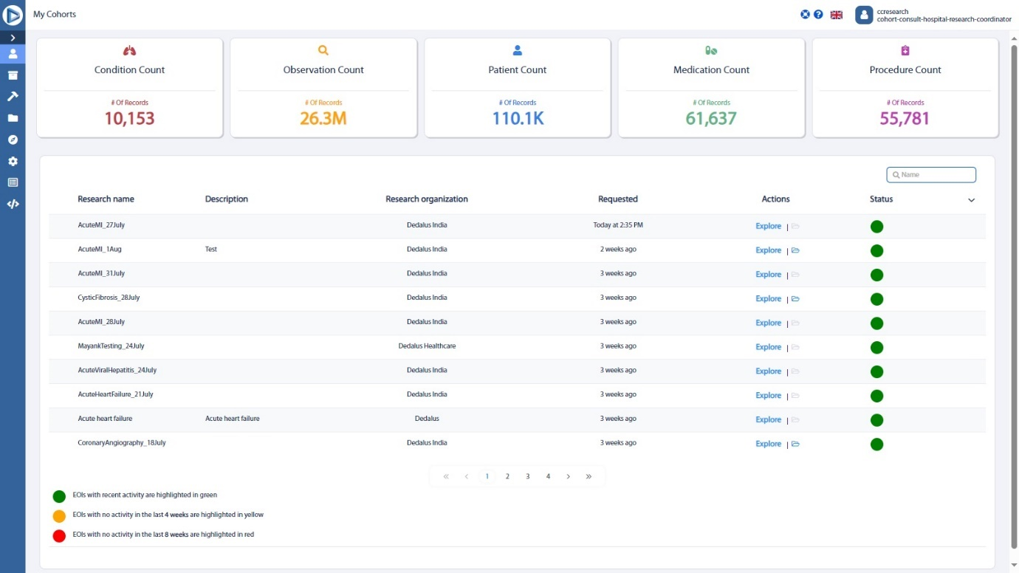

My Cohorts page

## Manage Cohort

In the My Cohorts page in the left menu, clicking **Explore** under Actions allows you to start the EOI enrollment process, you can;

* Review Cohort
* Contact researcher
* Ethics approval status
* Select suitable patient
* Inform patient
* Gather patient consent
* Aggregation of patients data

### Managing specific Cohort

1. Click **My Cohorts** in the left menu of T4C Edge portal; displays the **My Cohorts page.** The list of EOIs received with the details such as Research name, Description, Organization, Requested time, Actions and Status will be displayed.
2. Click **Explore** under Actions; displays the EOI enrollment steps.
3. Review the information provided about the research.
4. Click **Uploaded files** to review the multimedia files uploaded by external researcher.
5. In the new page, click **Download** to save the document.
6. Review the Cohort status. Select the Cohort status by clicking the dropdown.

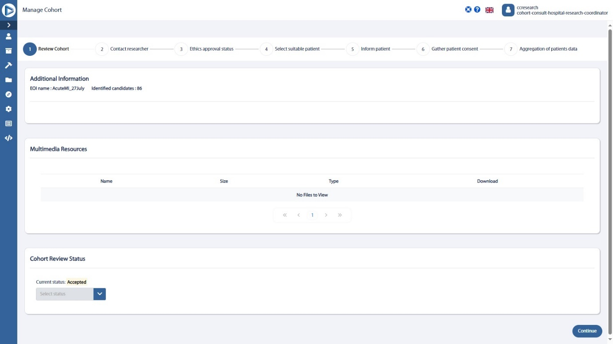

Review Cohort step

1. Click **Continue**; displays the **Contact information** of the researcher.
2. Review the **Researcher contact details** such as the Researcher name, Email, Phone, Organization and Address to contact the researcher if necessary.

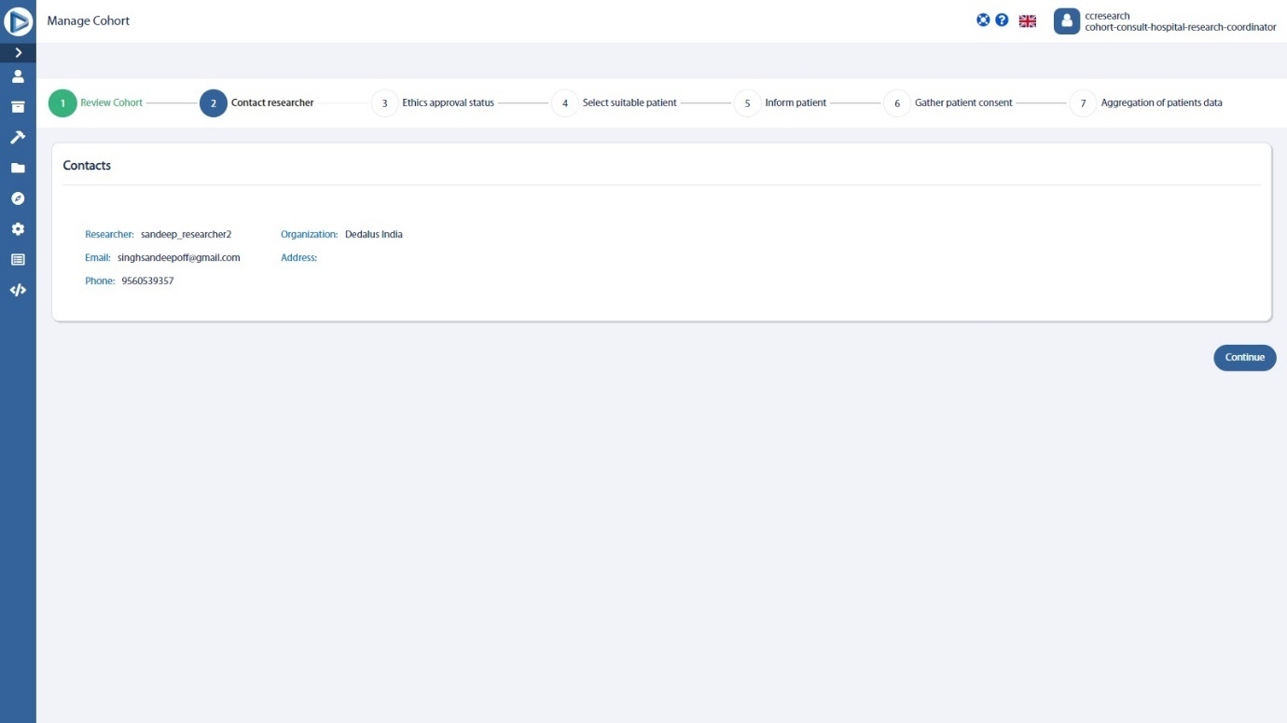

Contact researcher step

1. Click **Continue**; displays the **Ethics approval status.**
2. In the **Select status** dropdown, select the status of ethics approval.

|  |  |
| --- | --- |
| Status | Description |
| **Accepted** | The EOI is accepted. |
| **Rejected** | The EOI is rejected. |
| **In progress** | The EOI is in progress. |
| **Not started** | The EOI is not yet started. |
| **Not required** | The EOI is not required. |

Ethics approval status step

1. Click **continue**; displays the list of patients.
2. Review all the patients and select the patients identified as suitable for the research.

**Note:**

For patients who are already in another EOI, the relative row in the table is highlighted in blue.

Click the highlighted row for further details of the EOI in which the patient is involved.

1. Click **Download Excel** to download a document with all details such as **Patient ID, Patient Name, Gender, Age, Vital status, City, Country, Enrollment stage** displayed.

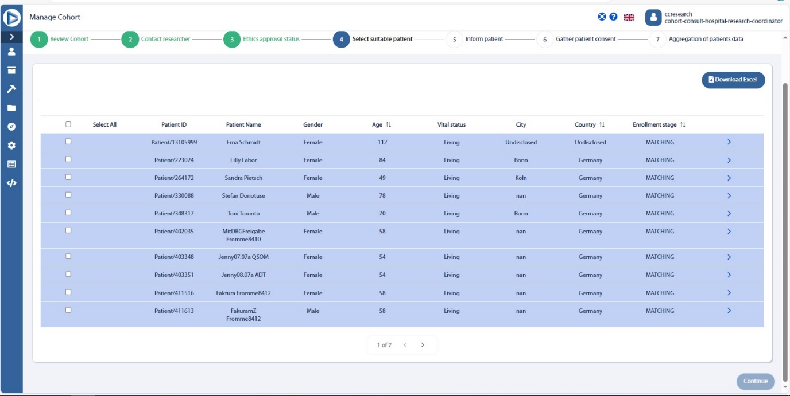

Select suitable patient step

1. Click **Continue**; displays the selected patient details and allows you to inform the patient.
2. In the informing patient step, click  under the enrollment stage; displays the contact methods and a text box to report any concerns collected from the patient.
3. Click **Type of contact** dropdown and select the mode of contact such as Phone, Email, Text message, Hospital visit and Other.
4. Click **# of times contact attempted** textbox to enter how many times the patient contacted.

If you delete the type of contact upon entry of the value in number of times and selection of the type of contact, then the **Save** button will be disabled and the following message will be displayed,

***Please select Type of Contact***

Similarly, if you delete the value in number of times upon selection of the type of contact and entry of the value in number of times, then the **Save** button will be disabled and the following message will be displayed,

***Please select # of times contact attempted***

1. Click  to add the other contact method.
2. Click **Patient Concerns** textbox to report any concerns collected from the patients and click **Save concern**.
3. Click **Send concerns via email** checkbox if you want to send an email to the Researcher responsible for the study.
4. Click **Continue** to gather the patient consent.

All the suitable patients should be contacted before proceeding to the next step.

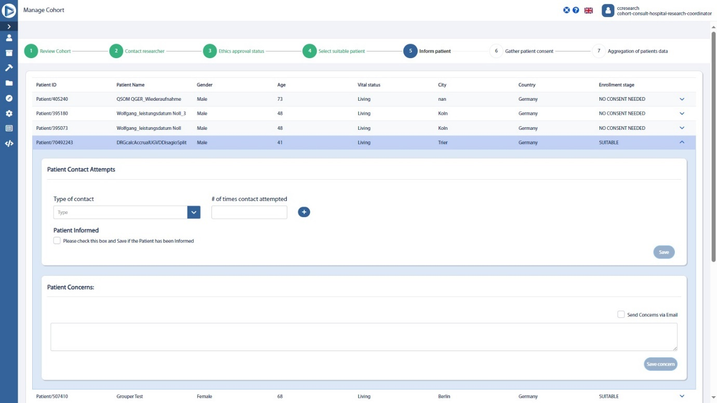

Inform patient step

1. Click a specific patient and a side menu appears where you can choose a consent option for that patient.

|  |  |
| --- | --- |
| Options | Details |
| **Consent provided** | Patient consent collected to share data with external research organization for the trial. |
| **Conditional consent provided** | Patient consent collected to share data with external research organization for the trial under descripted conditions. |
| **Consent denied** | Patient consent not provided to share data with external research organization for the trial. |

1. In the bottom part of the menu two button are available:
   1. **Save** : Allows you to save the selected consent option.
   2. **Download** : Allows you to download a pdf, containing the data sharing consent form, together with the patient’s general information and the consent option selected.

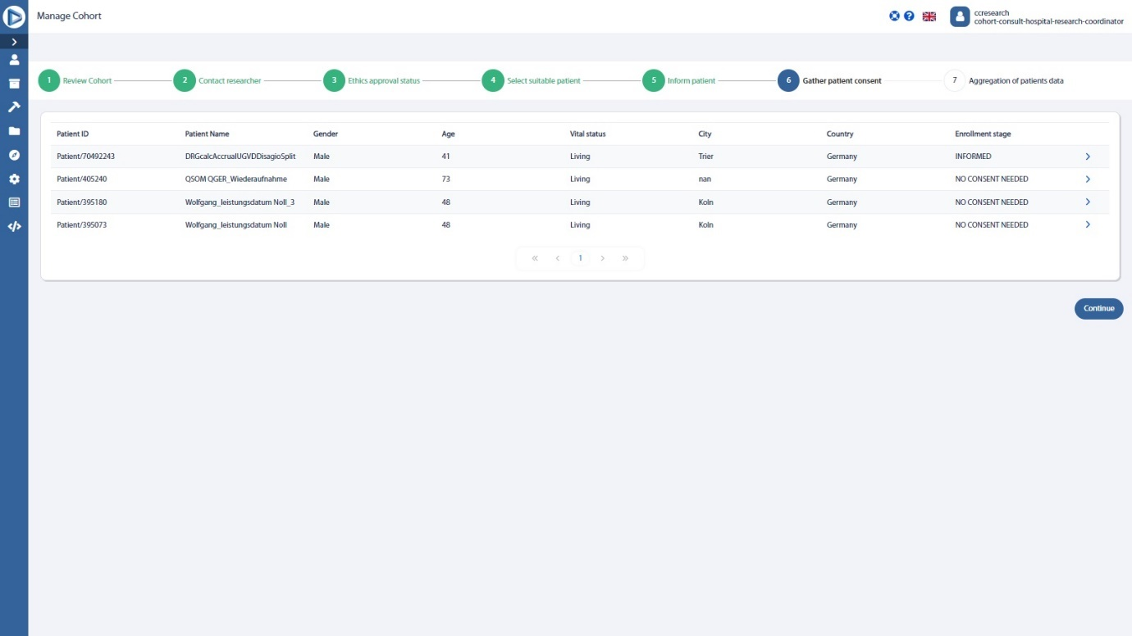

Gather patient consent

1. Click **Continue**; displays the details of the patient who were informed about the study and accepted to involve.

INSTRUCTION:

If a patient revokes data sharing consent when the information has already been shared, changing the consent, through the functionality available in the patient consent stage, will send an automatic email to inform the Researcher about the revoked consent.

1. Click **Complete and Move to History** to complete the EOI enrollment process and move the details to the History page.
2. Click **Complete** to complete the EOI enrollment process.

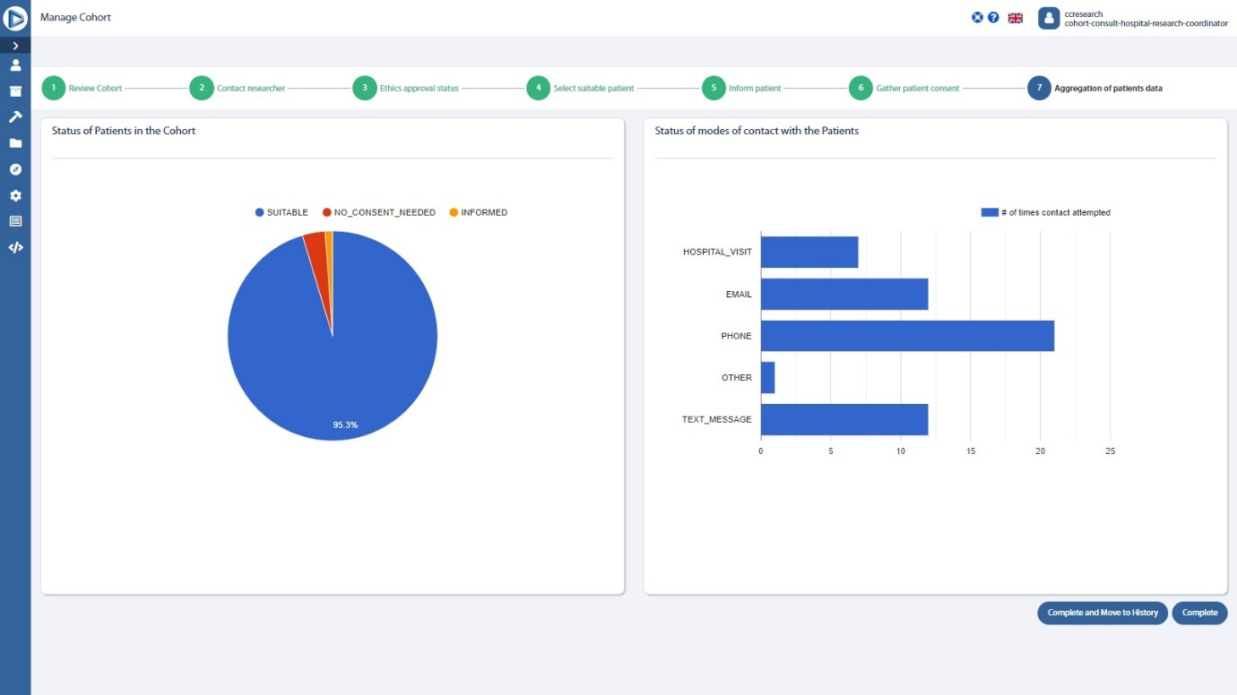

Aggregation of patients data

## Field and Button Description – My Cohorts page

|  |  |
| --- | --- |
| Name | Description |
| **Condition Analytics** | Any problem, diagnosis or clinical concept identified in a patient. |
| **Medication Statement Analytics** | Drug or ingredient. |
| **Observation Analytics** | Vital signs, clinical findings and Laboratory data. |
| **Patient Analytics** | Demographic information to support administrative procedures. |
| **Procedure Analytics** | Any activity performed on the patient as part of provision of care. |
|  | |
| **List view section** | |
|  | Clicking this allows you to search for the **research name.** |
| **Research details** | Displays the research details such as **Research name, Description, Research organization, Requested time, Actions, and the Status.**  Click **Explore** under Actions to start the enrolment process.  - EOIs with recent activity are highlighted in green.  - EOIs with no activity in the last 1 month are highlighted in yellow.  - EOIs with no activity in the last 2 months are highlighted in red. |

## Field and Button Description – Manage Cohort page

|  |  |
| --- | --- |
| Name | Description |
| **Review Cohort** | Allows you to review the EOI that is selected. |
| **Data Sharing Consent** | Displays the details of the data received. |
| **Multimedia Resources** | Displays the Multimedia resources if any available. |
| **Review EOI status** | Allows you to set the status for that EOI such as **Accepted, Rejected, In progress, On hold.** |
|  | Clicking this allows you to move to the next step. |
|  | |
| **Contact researcher** | Displays the **Contact details** of the researcher such as **Name** of the researcher, **Email, Phone number.**  Click **Continue** to move to the next step. |
|  | |
| **Ethics approval status** | Allows you to set the Ethics status such as **Accepted, Rejected, In progress, Not started, Not required.**  Click **Continue** to move to the next step.  **Note:**  If you click the next step without selecting any status, then the following message is displayed,  **“You can only move ahead if the Ethics Approval Status is Accepted”.** |
|  | |
| **Select suitable patient** | Displays the list of patients available for the specific query and the details such as **Patient ID, Patient Name, Gender, Age, Vital status, City, Country, Enrollment stage.**  Select the suitable patients for the research.  Click **Continue** to move to the next step. |
|  | Clicking this allows you to download the patient list as an Excel file. |
|  | |
| **Inform patient** | Displays the details of the selected patients. You can contact and inform the patients about the study. |
| **Contact** | Allows you to contact the patient via Phone, Email, Text message, Hospital visit, and other modes. You can also enter the number of times the contact attempted. |
| **Patient concerns** | You can provide the concerns of the patients if any after contacting the patients. |
|  | Clicking this allows you to send the patients concerns via Email. |
|  | Clicking this allows you to save the concerns. |
| **Collected concerns** | Displays the patient concerns if any.  Click **Continue** to move to the next step.  **Note:**  All the suitable patients should be contacted before proceeding to the next step. |
|  |  |
| **Gather patient consent** | Displays the details of the patients informed and allows you to gather the consent from the patient if they want to be involved in the study.  Click **Continue** to move to the next step. |
|  | |
| **Aggregation of patients data** | Displays the details of the patient who were informed about the study and accepted to involve. |
|  | Clicking this allows you to complete the EOI enrollment process and move the details to the History page. |
|  | Clicking this allows you to complete the EOI enrollment process. |

# Cohort History

This page displays the history of Expression of interest received. You can also search for the specific research and view the Cohort details.

## Field and Button description - Cohort History page

|  |  |
| --- | --- |
| Name | Description |
| **Cohort History page** | Displays the Cohort details such as Research name, Description, Research organization, Requested, and Actions. |

# Perform a research query – Cohort Builder

You can perform the research queries based on your requirements. This page allows you to perform the following activities:

* Build a new query
* View and use the previous history
* Save the research

## Build new query

You can build a new query in the Cohort Builder page that has lots of parameters which you can include or exclude by using **Inclusion/Exclusion criteria**. In the index dropdown, you can find the following options:

* Condition - Any problem, diagnosis or clinical concept identified in a patient.
* Medication statement - Drug or ingredient.
* Observation - Vital signs, clinical findings, and Laboratory data.
* Patient - Demographic information to support administrative procedures.
* Procedure - Any activity performed on the patient as part of provision of care.

You can set the index based on your requirements for building a query.

### Building new query

1. Click **Cohort Builder** in left menu of **T4C Edge portal**; displays the Cohort Builder page.
2. In the **Cohort Selection Criteria**, click the **Include/Exclude** dropdown; displays the Include and Exclude options.
3. Click **Include or Exclude**,
   * 1. You can add multiple inclusion criteria.
     2. You can add multiple exclusion criteria.
     3. You can add inclusion and exclusion criteria's simultaneously.
4. In the **Index** dropdown, select the required parameter.
5. Select the **specific tag** from the possible tags.
6. You can also select the gender by clicking **Gender** dropdown in the **Candidate Gender** field.
7. In the **Candidate Age Range** field, you can set the minimum and maximum age values.
8. In the **Candidate Age** field, you set the specific age of the patients for the search.
9. Click **Launch query**; query results will be displayed.
10. In the query results, you can
    1. Click  to **delete** the entire lane,
    2. Click  to **Enable/disable** the entire lane.
    3. Click  to **Add inclusion criteria** to query.
    4. Click to **Add exclusion criteria** to query.

Inside the grey field of the lane, cards displayed represent each criterion.

1. Click **Clear Criteria** to clear the current selection criteria set.

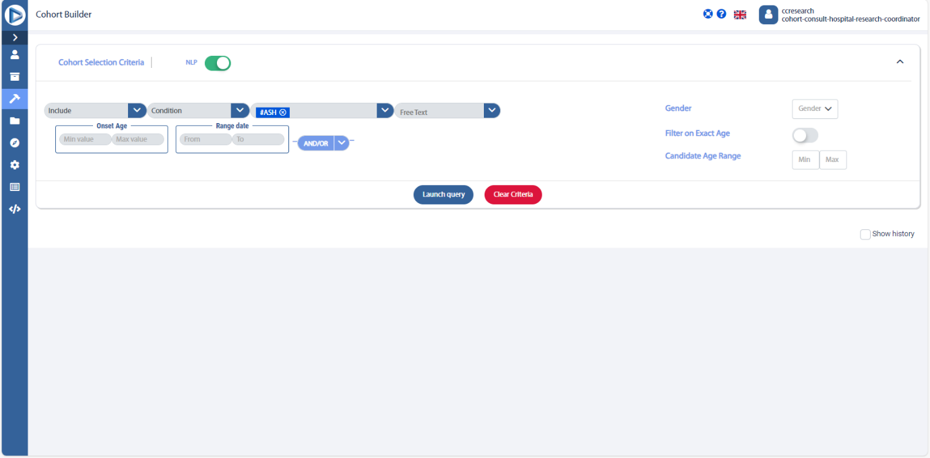

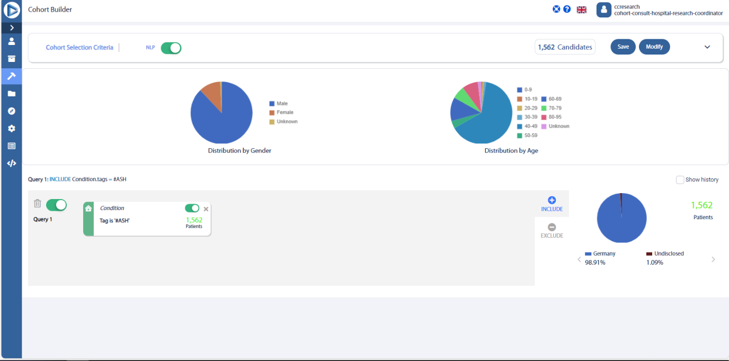

## View and use previous history

You can view the previous query history and use any of the query by restoring it.

### Viewing and using previous query history

1. In the **Cohort Builder** page; click **Show history** below the Launch query button.
2. On the right, you will find the **Query history** with specific information like date, query results, conditions applied and username.
3. Click **Restore** to view the chosen query search in Cohort Builder page.

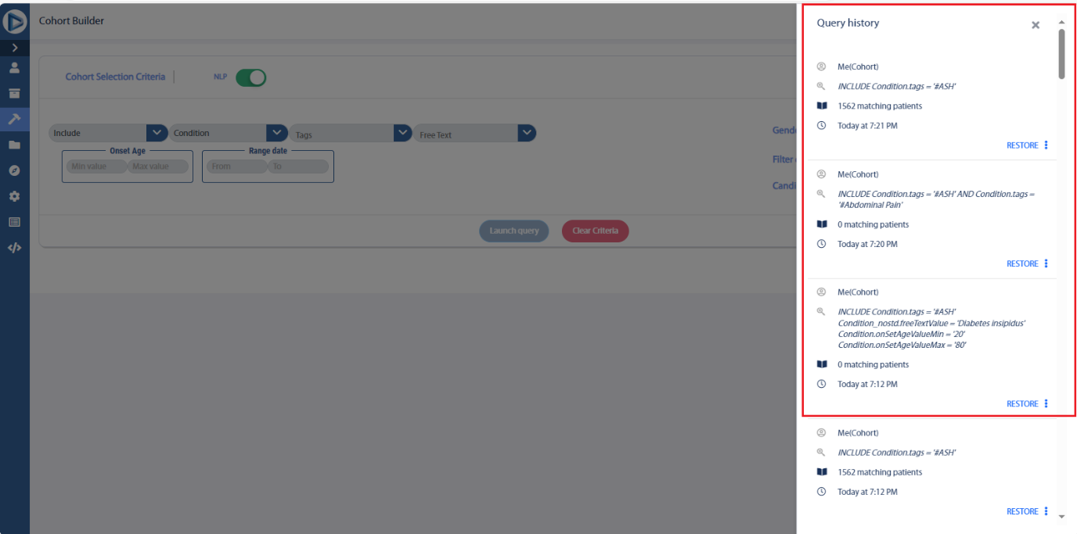

## Modify and Save query research

You can modify the query research if needed and save the query research and also keep the research queries as draft.

### Modifying and Saving query research

1. In the **Cohort Builder page**; above the cohort results; click **Modify** to modify your research query if needed.
2. In the **Cohort Builder page**; above the cohort results; click **Save** to save your research queries.
3. Complete the specifications of the research.
4. Click **Save**.

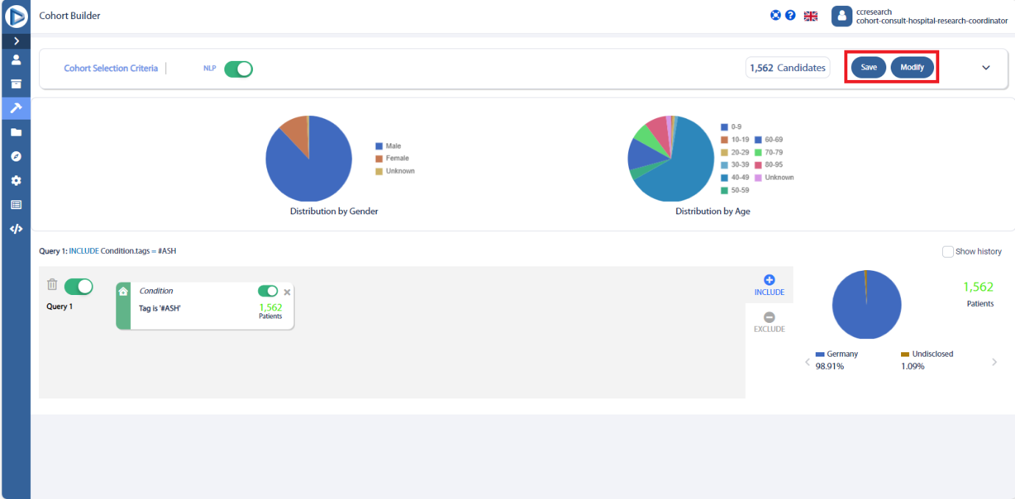

## Field and Button Description – Cohort Builder page

|  |  |
| --- | --- |
| Name | Description |
| **Cohort Builder** | Allows you to **Create queries and see query search history**. |
|  | |
| **Cohort Selection Criteria** | Displays the **Inclusion and Exclusion criteria options** and allows you to add Inclusion and Exclusion criteria based on your requirements. |
|  | This is the confidence score generated by the Natural Language Processing (NLP) model algorithm to show the accuracy of the output detected.  You can choose to include or exclude NLP from query search results. |
| **Condition Index** | Any problem, diagnosis or clinical concept identified in a patient. |
| **ImagingStudy Index** |  |
| **MedicationStatement Index** | Drug or ingredient. |
| **Observation Index** | Vital signs, clinical findings and Laboratory data. |
| **Procedure Index** | Any activity performed on the patient as part of provision of care. |
| **Onset Age Range** | Allows you to set the minimum and maximum range of onset age values. |
| **Range date** | Range date field allows you to search based on the recorded dates of the condition. |
| **Quantity value** | Quantity value field allows you to search for specific values for individual observations.  **Eg: Heart rate between 60-100.** |
| **Gender** | Allows you to select the gender of the patients. |
| **Filter on Exact Age** | Enabling this option allows you to set the specific age of the patients. |
| **Candidate Age Range** | You can set the Age range to view the list of patients in that range. |
| **Launch query** | Allows you to launch the query. |
| **Clear Criteria** | Allows you to clear the current selection criteria set. |
| **Show history** | Displays the **query history**. You can also restore the query by clicking . |
|  | |
| **Query results** | Query results with the patient count, Distribution by gender chart and Distribution by age chart will be displayed. |
|  | Allows you to delete the queries made. |
|  | Allows you to disable the card, that particular criteria will be excluded from the search, and this will instantly reflect on patient count. Card can be re-enabled at any point to add it to the query criteria. |
|  | Clicking this will show the particular query’s patient count. |
|  | Clicking this will exclude the particular query results from the patient count. |
|  | |
| **Geographical view** | Displays the Geographical representation of the query results. |
| **Save** | Allows you to save the research. You can save the research anytime during the process. |
| **Modify** | Allows you to modify the research. |

# My Saved Cohorts

The **My Saved Cohorts page** in the left menu of the T4C Edge portal provides the details of the research done. You can perform the following activities in this page,

* View the research
* Edit the research
* Duplicate the research
* Delete the research

## View research

You can view the research details.

### Viewing research

1. Click **My Saved Cohorts** in the left menu of **T4C Edge Portal**; displays the **My Saved Cohorts page**.
2. Search for the **Research Name**.
3. Click the blue row under **Actions** and select **View**.
4. In the new page, review the **Query results**.

## Edit research

You can edit the research general information such as **Research name, description, and Cohort builder criteria**.

### Editing research

1. Click **My Saved Cohorts** in left menu of **T4C Edge portal**; displays the **My Saved Cohorts page.**
2. Click on the top right **search bar** to search an specific research name.
3. Under the **Actions,** click **Edit** to edit research general information or queries included.
4. In this new page you can edit:

* Research name
* Research description
* Cohort builder criteria

1. Click **Go to Cohort Builder** to re-apply all criteria.
2. Include any new criteria or edit the existing ones as described in the Perform a query chapter.
3. Click **Update research** in the top right button of the page.
4. Click **Save or Cancel** to update the perform research results.

#### Field and Button description – Edit Research details page

|  |  |
| --- | --- |
| Name | Description |
| **General info tab** | Allows you to edit the **Research name and Description.** |
|  | Clicking this allows you to edit the research query in the Cohort builder page. |
|  | |
| **Upload files tab** | Allows you to view the uploaded files and upload the new files. |
|  | Clicking this allows you to upload a new file. |
|  | Clicking this allows you to cancel uploading the file. |
|  | |
|  | Clicking this allows you to cancel editing the research. |
|  | Clicking this allows you to update the research. |

## Duplicate research

You can duplicate the specific research.

### Duplicating research

1. Click **My Saved Cohorts** in left menu of **T4C Edge portal**; displays the **My Saved Cohorts page.**
2. Click on the top right **search bar** to search an specific research name.
3. Under the **Actions,** click **Duplicate** to create a copy of this research.

## Delete research

You can also delete the research permanently.

### Deleting research

1. Click **My Saved Cohorts** in the left menu of **T4C Edge Portal**; displays the **My Saved Cohorts page**.
2. Search for the **Research Name**.
3. Click the blue row under **Actions** and select **Delete**.
4. Click **Ok** to delete the research permanently.

## Subscribe and Favorite research

You can subscribe the research to receive alerts when the research is updated and add the research as favorite.

### Subscribing the research and adding the research as favorite

1. Click **My Saved Cohorts** in left menu of **T4C Edge portal**; displays the **My Saved Cohorts page.**
2. Click on the top right **search bar** to search a specific research name.
3. Click **Subscribe** to receive alerts any time this research is updated.
4. Click **Favorite** to add as favorite in your page.

## Field and Button Description – My Saved Cohorts page

|  |  |
| --- | --- |
| Name | Description |
| **My Saved Cohorts page** | Displays the details such as **Research name, Description, Username, Last updated, Status, Actions, Favourites, and Subscribed research.** |
|  | Clicking this tab will display the details of **recent Research.** |
|  | Clicking this tab will display the details of research that has been added as **favourites.** |
|  | Clicking this tab will display the details of research that has been **subscribed.** |
|  | Clicking this tab allows you to **search for research** from the list. |
|  | Displays the research details of the **Pending requests**. |
|  | This tab allows you to navigate between the **pages**. |

# Overview of Edge available resources – Discover page

This page gives the details of Condition Analytics, Observation Analytics, Patient Analytics, Medication Statement Analytics, Procedure Analytics.

1. Click **Discover** in left menu of T4C Edge portal.
2. The upper part of the page displays the Subject exploration feature with a counter of the patients available, per index.
3. Immediately below, the list of indexes is displayed: by clicking on one index, you can explore the total count available, for the specific index.
4. Each count is displayed with a preview of the fields and respective values available.

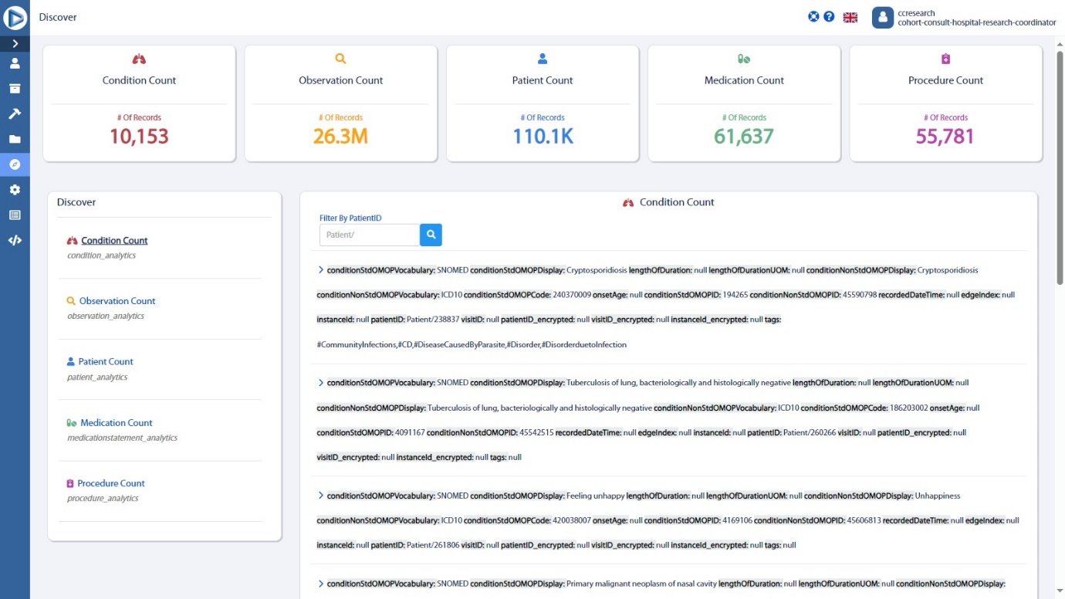

# Settings

In the **Settings page,** you can **create a new user, edit user, delete user** and **setup the NLP score**.

## User management

You can manage the T4C Edge portal by logging in with Hospital Researcher Coordinator credential and you can also perform the following activities:

* Create new user
* Edit user
* Delete user

### Create new user

You can **create** a new user in the **Settings** page.

**Restriction:**

Only users with the Hospital Research Coordinator role have the permission to create a new user.

#### Creating a new user

1. Click **Settings** in the left menu of T4C Edge portal; displays the **Settings page.**
2. Enter the **First Name, Last Name, Email, Username** for the new user in **New user setup box**.

**Restriction:**

This email address cannot be edited by the user and will be used for login and password resets.

1. Enter a **telephone number**.

Syntax: “0” + country code + phone number.

Example: 0 32 123456789

1. Select the **role**.
2. Click **Save**.

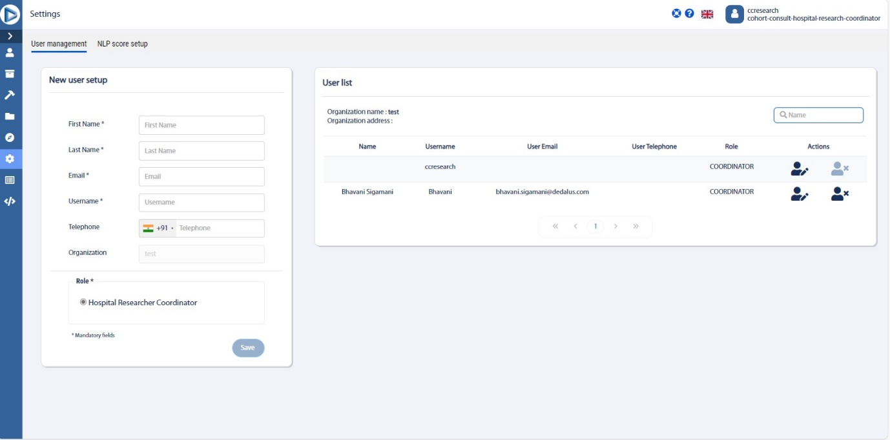

Settings page

### Edit user

You can **edit** the user information in the **Settings** page.

#### Editing a user

1. Click **Settings** in the left menu of T4C Edge portal; displays the **Settings page.**
2. Click in the user list pane in the **User management settings** page, displays the popup window where you can edit the user details such as **First Name, Last Name, Email, Username, Telephone number,** and select or deselect the **Show deceased candidate** checkbox and **User enabled** checkbox**.**
3. Click **Confirm** to save your changes.
4. Click **Cancel** to discard the changes.

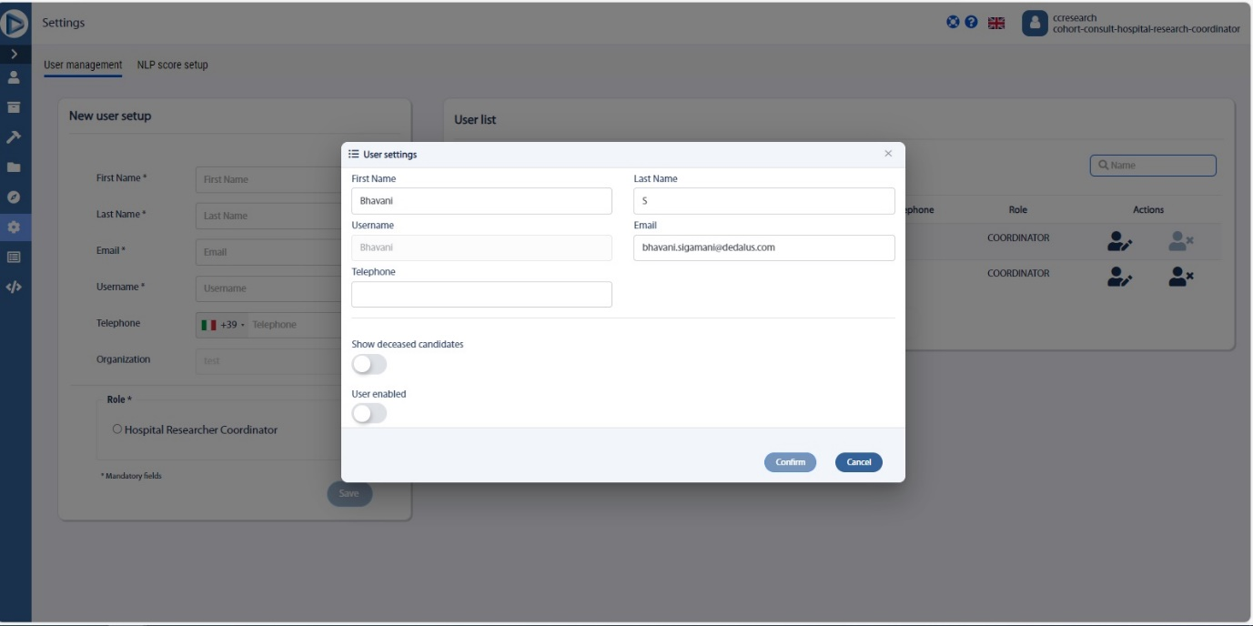

Figure: User management (Editing user in User list field)

### Delete user

You can also **delete** the user in the **Settings** page.

#### Deleting a user

1. Click **Settings** in the left menu of T4C Edge portal; displays the **Settings page.**
2. Click  in the user list pane in the **User management settings** page, displays the popup window which has the following message,

***Are you sure you want to delete?***

1. Click **Confirm** to delete the user.
2. Click **Cancel** to discard.

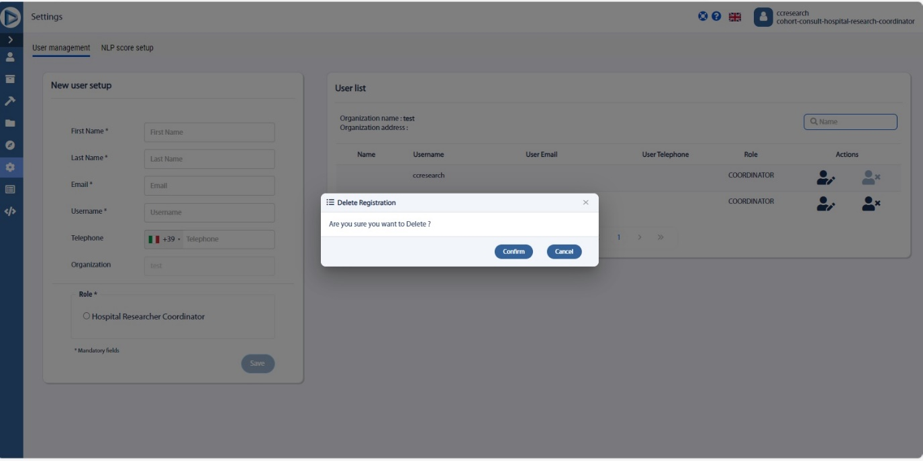

Figure: User management (Deleting user in User list field)

## NLP score setup

In the Settings page, you can also set up the NLP score based on your requirements.

The NLP score indicates how sure the NLP model is that the correct entity recognition and normalisation has taken place.

There are three ranges of NLP confidence score, they are **High, Medium and Low**.

### Setting NLP score

1. Click **Settings** in the left menu of T4C Gravity portal; displays the **Settings page.**
2. In the **Settings** page, click NLP score setup; displays the **NLP Score setup**.
3. Set the NLP score based on your requirements.

**Note:**

The NLP confidence score should be set in the condition **High>Medium>Low.**

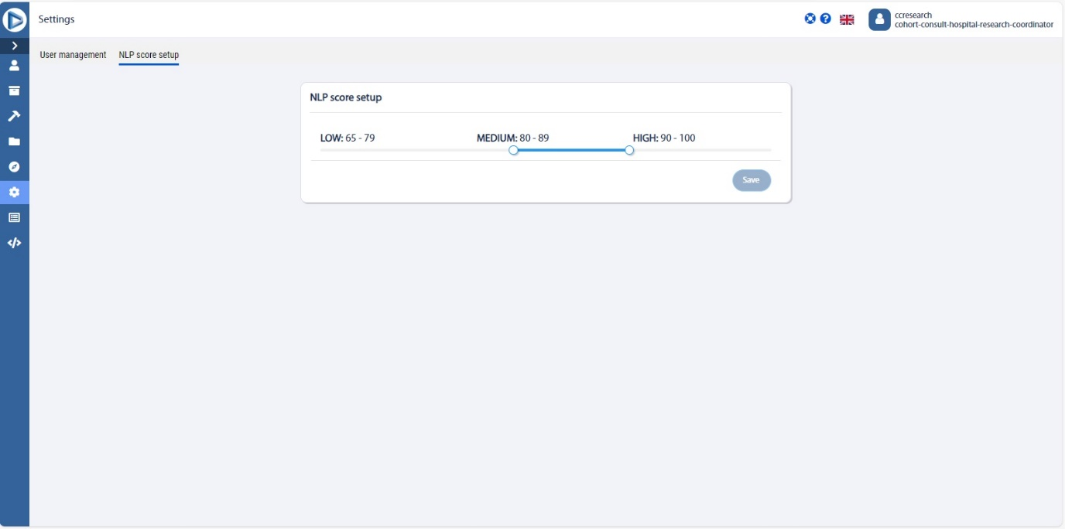

## Field and Button Description – Settings page

|  |  |
| --- | --- |
| Name | Description |
| **User management tab** | |
| **New user setup pane** | Allows you to create new user by providing **First Name, Last Name, Email, Username, Telephone** and **Organization.** |
| **Role** | Allows you to select the role for the user such as i.e. **Hospital researcher coordinator.** |
| **Save** | Saves the user details. |
|  | |
| **User list section** | Details of the user created such as **Organization name, Organization address, Name, User Email, User Telephone, Role** and **Actions.** |
| **Search** | Click to search for the user. |
| **Edit and Delete** | Clicking  allows you to edit the user and clicking  allows you to delete the user.  **Note:**  When you try to **Edit**, you will get the popup window that allows you to edit the user details. Click **Confirm** to make changes or click **Cancel** to discard the changes.  When you try to **Delete** a user, the following popup message will be displayed,  ***Are you sure you want to delete the user's registration?***  Click **Confirm** to delete the user or **Cancel** to discard the deletion. |
|  | |
| **NLP score setup** | Allows you to set the NLP score.  **Note:**  The NLP confidence score should be set in the condition High>Medium>Low. |
|  | Allows you to save the NLP score. |

# Logs

This section gives you the details about the patients enrolled.

## Review internal organization history

You can review the internal organization history such as username, date and time, action performed and so on.

### Reviewing internal organization history

1. Click **Logs** button on the left menu; displays the **Logs page.**
2. Review the information specified:
   1. **Date/Time**: Timestamp of the action.
   2. **User**: Indicates the user who performed the action.
3. **Action performed**: Contains the description of the action performed. This column will display the actions such as Query executed, EOI Review accepted, No Consent Needed, Research created and so on.

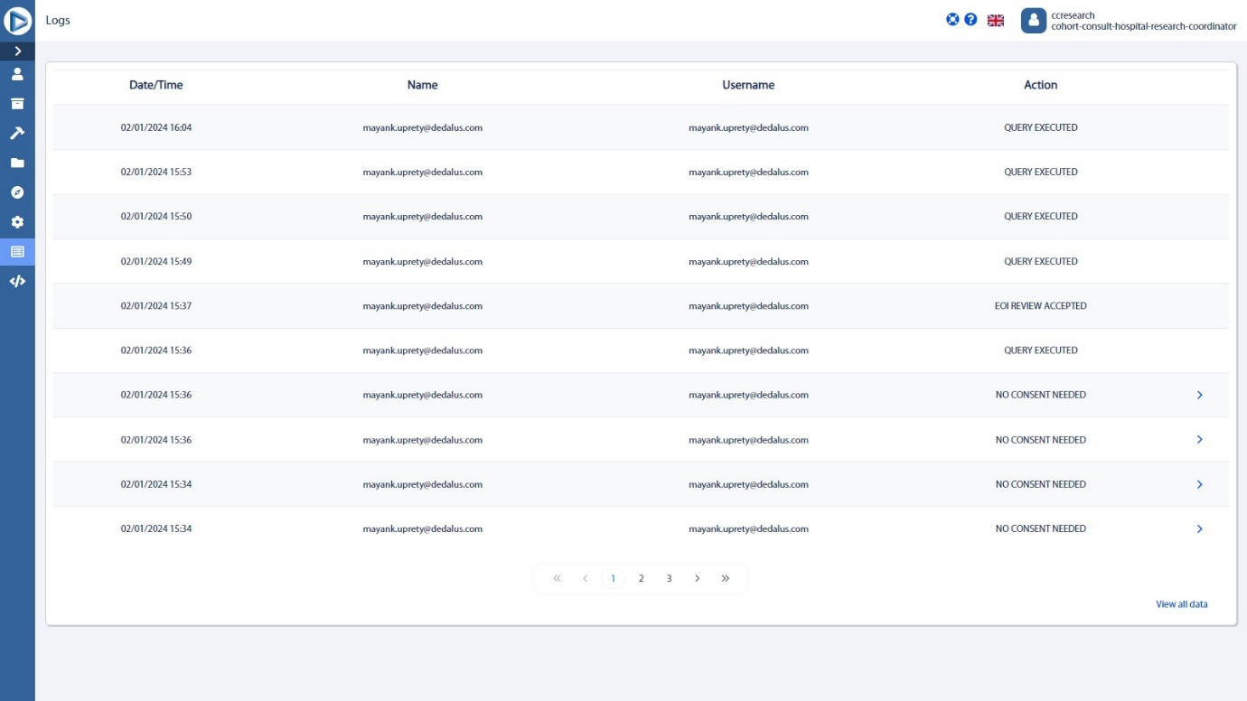

## Field and Button description – Logs page

|  |  |
| --- | --- |
| Name | Description |
| **Logs** | Displays the activity logs of the patients enrolled such as **Date/time of the action, Username, Organization name, and Action performed**. |
|  | Clicking this allows you to view the data of all the pages. |
|  | This allows you navigate between the pages. |

# Documentation

In this section, you can explore comprehensive guides to navigate through the portal’s features efficiently.

1. Click **Documentation** in left menu of **T4C Edge portal**.
2. Click **Download file** to save a local version of the user manual.
3. Click **Open file** to open in browser the user manual.

## Field and Button description

|  |  |
| --- | --- |
| Name | Description |
| **Guides section** | This provides in-depth information on the **key concepts of T4C Edge portal** with useful background information and explanation.  Clicking  allows you to open the file in the browser.  Clicking  allows you to download and save the file. |

# References

## Generic references

### Top menu buttons

|  |  |
| --- | --- |
| Button | Description |
|  | Contact us |
|  | Favorite query |
|  | Light screen mode |
|  | Dark screen mode |
|  | Profile |

### Languages

|  |  |
| --- | --- |
| Flag | Language |
|  | Italian |
|  | English |
|  | French |
|  | German |

### Left menu

|  |  |  |
| --- | --- | --- |
| Button | Name | Description |
|  | **My EOIs** | Manage Expression of Interest within the organization. |
|  | **Cohort Builder** | Create queries and see query search history. |
|  | **Discover** | Search for FHIR specific information |
|  | **Settings** | Manage the user/organization account. |
|  | **Clinalytix NLP Service API** | Natural Language Processing demonstrator to enter clinical text for English and German and generate NLP output |
|  | **Logs** | See activity logs of users and EOI requests |
|  | **Documentation** | Useful information to guide you through the assets of the portal. |

# Appendix

## Glossary

Terms and abbreviations are expanded below and, where applicable, expanded on their first occurrence in the text.

|  |  |
| --- | --- |
| Abbreviation | Description |
| **T4C** | Trials4Care |
| **EOI** | Expression of Interest |
| **API** | Application Programming Interface |
| **NLP** | Natural Language Processing |

## FAQ

***What is an expression of interest?***

*The expression of interest (EOI) is a request send by an external research organization to data provider to match a cohort to participate to a specific trial.*

***How can I retrieve an expression of interest as a Hospital coordinator user?***

*Each time an expression of interest is sent, you will receive a notification email. The email contains a link that, once clicked, will redirect to your restricted area of the portal and will show the new EOI, in the expression of interest page.*

***How to review available patients to enroll in a study?***

*You can review patients once you start the enrollment process.*

***How can I perform searches on available resources?***

*It is possible to perform searches, by typing in any Inclusion/Exclusion criteria in the dedicated page of the portal, i.e. the Cohort Builder.*

***Can I explore all the contents available on the Edge?***

*It is possible to have a broader knowledge of the contents available on the portal, by consulting the different indexes in the Discovery Page.*

***Can I create a new user?***

*It is possible to create a new user by accessing to the Settings page and typing in all the required information inside the dedicated form. It is important to point out that only users with the Hospital Research Coordinator role have the permissions that enable such functionality.*

# Amendment History

|  |  |  |  |
| --- | --- | --- | --- |
| T4C Version | Date | Actioned By | Description |
| *1.0.0* | *25 May 2023* | *Sushmitha D* | *Draft created.* |
| *1.0.0* | *28 June 2023* | *Sushmitha D* | *Updated the* ***Settings, My EOIs, Perform a research query sections*** *for sprint30_alpha-0.1.* |
| *1.0.0* | *11 July 2023* | *Sushmitha D* | *Updated the* ***Settings, My EOIs, Perform a research query sections*** *for sprint31_alpha-0.1.* |
| *1.0.0* | *07 August 2023* | *Sushmitha D* | *Updated for sprint33_alpha-0.1.* |
| *1.0.0* | *30 August 2023* | *Sushmitha D* | *Updated for sprint34_alpha-0.2.* |
| *1.0.0* | *05 October 2023* | *Sushmitha D* | *Updated for sprint36_alpha-0.1* |
| *1.0.0* | *10 November 2023* | *Sushmitha D* | *Updated the* ***Section 6 – Perform research query and section 7 – My research*** *for sprint37_alpha-0.1.* |
| *1.0.0* | *22 Novemeber 2023* | *Sushmitha D* | *Updated for sprint38_alpha-0.1.* |
| *1.0.0* | *08 December 2023* | *Sushmitha D* | *Updated the* ***Section 3 - settings and removed the Clinalytix NLP service API section*** *for sprint39_alpha-0.1.* |
| *1.0.0* | *03 January 2024* | *Sushmitha D* | *Updated the* ***Section 5 – Perform Research Query – Cohort Builder (updated the screenshots and field and button description)***  ***Section 9 – Logs (Updated the screenshot and field and button description)*** *for sprint40_alpha-0.1.* |
| *1.0.0* | *17 January 2024* | *Sushmitha D* | *Added the* ***My Saved Cohorts section*** *and updated the* ***Cohort Builder section*** *for sprint41_alpha-0.1.* |
| *1.0.0* | *08 February 2024* | *Sushmitha D* | *Updated the screenshots in* ***Section 4 – Cohort History and Section 5 - Perform Research Query – Cohort Builder*** *for sprint42_alpha-0.1.* |
|  |  |  | *No updates in Spirnt43.* |
| *1.1.0* | *26 March 2024* | *Bhavani S* | *Updated the screenshots in* ***Section 3 - My Cohorts*** *and updated* ***the Section 3.1.1 - Managing specific Cohort*** *for sprint44_alpha-0.1.* |
| *1.1.0* | *15 April 2024* | *Bhavani.S* | *Updated the* ***Section 10 – Documentation, Section 3.3.- Manage Cohort page (Field and button description),*** *added the* ***Section 8.1 - User management*** *and updated all the**topics* ***under Section 8 – Settings*** *for Sprint45_alpha-0.1.* |
| *1.1.0* | *09 May 2024* | *Bhavani.S* | *No updates for Sprint46_alpha-0.1 (Only UI changes)* |
| *1.1.0* | *29 May 2024* | *Bhavani.S* | *Updated the* ***Section 5.1.1 - Building new query, Section 5.4 - Field and Button Description – Cohort Builder page*** *and its screens for Sprint47_alpha-0.1.* |